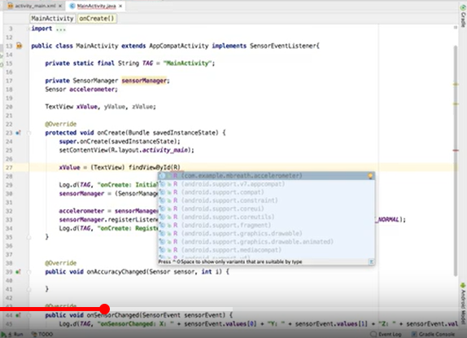

package com.example.myapplication;
import android.content.Context;
import android.hardware.Sensor;
import android.hardware.SensorEventListener;
import android.hardware.SensorManager;
import android.os.Bundle;
import android.widget.TextView;
import androidx.activity.EdgeToEdge;
import androidx.appcompat.app.AppCompatActivity;
import androidx.core.graphics.Insets;
import androidx.core.view.ViewCompat;
import androidx.core.view.WindowInsetsCompat;
import android.util.Log;
import android.hardware.SensorEvent;
import com.google.ai.client.generativeai.common.shared.Content;
public class MainActivity extends AppCompatActivity implements SensorEventListener {
private static final String TAG = "MainActivity";
private SensorManager sensorManager;
private Sensor accelerometer;
private TextView xValue, yValue, zValue;
@Override
protected void onCreate(Bundle savedInstanceState) {
super.onCreate(savedInstanceState);
setContentView(R.layout.activity_main);
xValue = findViewById(R.id.xValue);
yValue = findViewById(R.id.yValue);
zValue = findViewById(R.id.zValue);
Log.d(TAG, "onCreate: Initializing Sensor Services");
sensorManager = (SensorManager) getSystemService(Context.SENSOR_SERVICE);
if (sensorManager != null) {
accelerometer = sensorManager.getDefaultSensor(Sensor.TYPE_ACCELEROMETER);
sensorManager.registerListener(this, accelerometer, SensorManager.SENSOR_DELAY_NORMAL);
Log.d(TAG, "onCreate: Registered accelerometer listener");
}
}
@Override
public void onAccuracyChanged(Sensor sensor, int accuracy) {
// You can handle accuracy changes here if needed
}
@Override
public void onSensorChanged(SensorEvent event) {
Log.d(TAG, "onSensorChanged: X: " + event.values[0] + " Y: " + event.values[1] + " Z: " + event.values[2]);
xValue.setText("xValue: " + event.values[0]);
yValue.setText("yValue: " + event.values[1]);
zValue.setText("zValue: " + event.values[2]);
}
}

